John Smellie

University of Leicester

Associated Academic and Honorary Research Staff

https://www2.le.ac.uk/departments/geology/people/smellie-jl

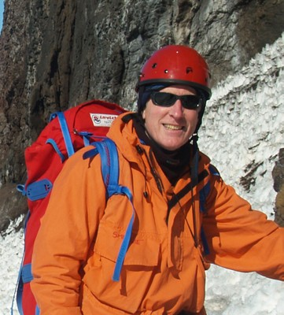

John Smellie is a volcanologist with principal interests in glaciovolcanism (eruptions beneath ice sheets) and its application to palaeo-ice sheet reconstruction. Prior to moving to Leicester University (UK) in 2010 he spent 35 years working for the British Antarctic Survey (BAS), principally as Senior Volcanologist & Project Leader. Although his major geographical focus has been the northern Antarctic Peninsula region, he has worked mainly on volcanic and associated glacial sedimentary rocks right across Antarctica, from the sub-Antarctic active volcanic South Sandwich Islands, through the Antarctic Peninsula and very remote Marie Byrd Land to East Antarctica (northern Victoria Land). In addition he has worked extensively on glaciovolcanic rocks in Iceland. A prolific author, he has > 190 publications and is editor or co-editor of 10 scientific volumes. He is also sole author of an invited comprehensive review of the geology of the entire Antarctic Peninsula region, the first major account for 25 years. He has successfully completed 26 field seasons in Antarctica (including as Chief Scientist on two Antarctic cruises) and 10 in Iceland; was awarded a Polar Medal for his scientific research by Her Majesty the Queen (UK); has Service Medals from the American and Italian Antarctic Programmes; has three geographical places in Antarctica named after him (by UK and Spain); is co-founder & Chair of AntVolc, the SCAR Expert Group on Antarctic Volcanism [https://antvolcscar.wordpress.com/]; serves on the UK National Committee for Antarctic Research; and was the Earth Sciences Editor for the journal Antarctic Science. In addition to his Leicester professorship, he was awarded a personal chair at Lancaster University (UK) and a Departmental Research Fellow at Aberystwyth University. Current research activities are focused on collaborative studies with geologists of the Italian, American and New Zealand Antarctic programmes aimed mainly at reconstructing critical parameters of the East Antarctic Ice Sheet in northern Victoria Land during the past 20 million years.

